**Ordering Management System**

**Software Requirements Specification**

***for***

***SoftServe University, Inc.***

**Version 1.1**

March, 2015

***Table of contents***

1. Introduction

1.1 Purpose

1.2 Scope

1.3 Definitions, Acronyms, Abbreviations

1.4 References

2. Overall Description

2.1 Product Perspective

2.2 Product Features

2.2.1 User interfaces (pages):

2.2.2 User Classes and Characteristics

2.3 System Requirements

3. System Features

3.1 ‘Login’ page

3.1.1 Process Overview

3.1.2 Functional requirements

3.1.3 Error messages

3.2 ‘Administrator’ role

3.2.1 ‘Administration’ tab

3.2.2. Users’ Table

3.2.3. ‘New User’ page

3.2.4 ‘Edit User’ page

3.2.5 ‘Delete’ button functionality

3.2.6 ‘Create report’ page

3.2.7 ‘User Info’ tab

3.3 ‘Merchandiser’ role

3.3.1 ‘Ordering’ tab

3.3.2 ‘Edit Order’ page

3.3.3 ‘User Info’ tab

3.4 ‘Customer’ role

3.4.1 Ordering’ tab

3.4.2 ‘Create new order’ page of ‘Ordering’ tab

3.4.3 ‘Add Item’ page of ‘Ordering’ tab

3.4.4 ‘User Info’ tab

3.5 ‘Supervisor’ role

3.5.1 ‘ Item Management’ tab

3.5.2 ‘Add product’ page

3.5.3 ‘Edit’ page

3.5.4 ‘Delete’ action

3.5.5 ‘Save Report’ functionality

3.5.6 ‘User Info’ tab

***1. Introduction***

***1.1 Purpose***

The objective of this project is to reduce employee’s efforts on managing orders and to provide merchandisers and supervisors with more up to date and relevant information.

This goal is going to be reached by creating an application that would allow to manage and store orders with client-server architecture.

This document describes requirements for the Order Management System. It is organized into the following sections:

* Functional Requirements,
* Non-Functional Requirements.

***1.2 Scope***

This document describes detailed requirements of the application functionality, establishes limitations and constraints that should be considered when designing the application.

The Order Management System allows users to:

* log in to the system;
* create new users;
* manage existing users;
* log out from the the system;
* give to users some role;
* give every role user its own possibilities;

***1.3 Definitions, Acronyms, Abbreviations***

|  |  |
| --- | --- |
| **Abbreviation** | **Sense** |
| OMS | Order Management System |
| SRS | System Requirements Specification |

***1.4 References***

The same functions to all roles of users where are some table informaton are described in Table 1.

|  |  |  |
| --- | --- | --- |
| **Page Item** | **Action** |  |
| First | Returns the information about users from the first page in the Users’ grid. The ‘First’ button is disabled if current page is the 1st one. | Backward’ and ‘First’ buttons should be inactive if user is on the first page. ‘Forward’ and ‘Last’ buttons should be inactive if user is on the last page.  All buttons should be inactive, if number of items is 10 or less when displaying 10 items per page and 5 or less when displaying 5 items per page. |
| Last | Returns the information about users from the last page in the Users’ grid. ‘Last’ button is disabled if current page is the last one. |
| Backward | Returns the information about users from the page by one step back. ‘Backward’ button is disabled if current page is the 1st one. |
| Forward | Returns the information about users from the page by one step forward. ‘Forward’ button is disabled if current page is the last one. |
| Show 10 items / Show 5 Items | Link ‘show 10 Items’ (displayed by default) means that for the present moment only 5 users are shown per page. Clicking on this link forces showing of 10 users per page and link is changed to ‘Show 5 Items’. |
| Page#: | Label shows current page number and total pages. For example: Page #: 1 of 3 indicates that user is on first page, totally 3 pages are present. | |
| The ‘English’ and ‘Українська’ links | Allows user to change localization of page. The ‘English’ is enabled by default; it means that English localization is enabled. The ‘Українська’ link changes localization to Ukrainian. Currently selected option is displayed in bold. | |
| Logout | Logout button is present in the right upper corner of every page or tab of logged in user. Logs off the user after pressing on it and returns him to ‘Login’ page. Logout button looks like white cross on red circle. | |

***Table 1***

***2. Overall Description***

***2.1 Product Perspective***

Order Management System is considered to be the most reliable, safe and secure management solution in the net. Its architecture follows the best practices in the development of e-commerce software at the same time introducing the highly effective service distribution concepts.

***2.2 Product Features***

***2.2.1 User interfaces (pages):***

‘Login’ page‘

User Info’ tab

Administration’ tab‘

‘Ordering’ tab

‘Item Management’ tab

***2.2.2 User Classes and Characteristics***

There are four classes of users:

* Customer is a person who can create new orders.
* Merchandiser can check information about orders.
* Supervisor is able to edit information about products and create new products.
* Administrator is responsible for managing users’ list. He can check information about orders.

***2.3 System Requirements***

Application is intended to run on following system:

OS: Windows XP - 8.1, Linux, Mac OS;

Browsers: Google Chrome v31., Mozilla Firefox v.36.0.4, Opera v.28.0, Internet Explorer v. 11, Safari 8.0.

***3. System Features***

***3.1 ‘Login’ page***

***3.1.1 Process Overview***

Every registered user who wants to enter the system can log in by entering ‘User Name’ and ‘Password’. After entering ‘User Name’ and ‘Password’ the system checks its correctness. If user name and password are correct, the user is logged into the system, if not, the system notifies user about it and gives him another try. After successful login, Order Management System opens new window. The specialty is that different users see different tabs. ‘Login’ page is depicted in Figure 1 below.

***3.1.2 Functional requirements***

* ‘User Name’ field is empty by default (if user name was not remembered previously on this computer).
* ‘Password’ field is empty by default. Symbols entered in ‘Password’ field are transformed in asterisks at once after entering.
* ‘Login’ button is always enabled. Validation is performed by pressing ‘Login’ button in the following order: ‘User Name’, ‘Password’.
* ‘Reset’ button clears data in fields.
* ‘Remember me’ option saves last entered user name on current PC.

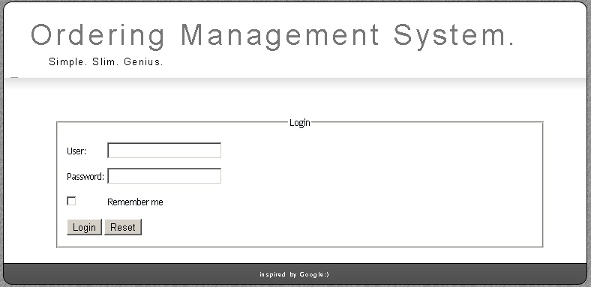

Figure 1. ‘Login’ page

***3.1.3 Error messages***

The system does not let user be logged in situations described below and error message will appear below corresponding fields.

When ‘User Name’ is empty and User clicks on ‘Log in’ button or Incorrect User Name is entered in the field and User clicks on ‘Log in’ button user receive following message ”Such user does not exist in the system – please try again.”

When ‘Password’ field is empty and user clicks on ‘Log in’ button or Incorrect Password is entered in the Password field and User clicks on ‘Log in’ button user receive following message Password is incorrect – please try again.

***3.2 ‘Administrator’ role***

Administrator sees the following tabs: ‘Administration’ and ‘User Info’. ‘User Info’ tab is opened by default. Administrator can switch between tabs by clicking on the corresponding tab. Tabs don’t change default state after switching between them.

***3.2.1 ‘Administration’ tab***

Administration tab is used for creating new and managing existing users. On this page Administrator can create new user, search existing user, delete existing user from the system. Depicted Figure 2.

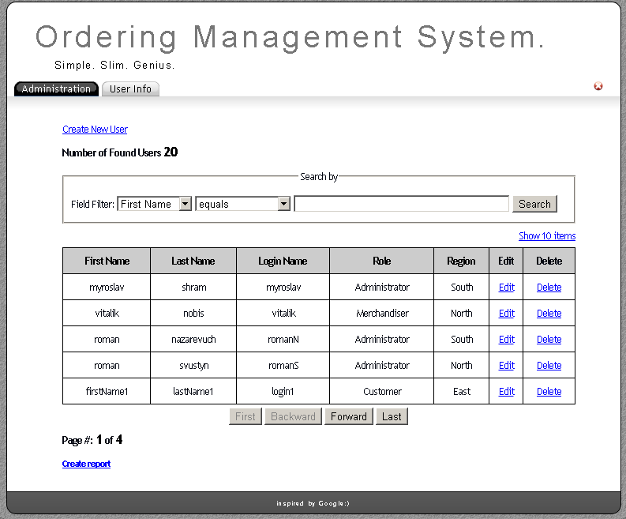

Figure 2. ‘Administration’ tab

The ‘Administration’tab page has following options:

Create New User - navigates to the ‘New User’ page with the default entries to create a new user;

Number of Found Users - shows the number of found users during the last search. In case search was not performed, than this amount is equal to number of all users that exist in system;

Search area- allows to do search when 3 fields: ‘Select Field’ ,‘Select Condition’ and Text box are filled in. Detailed description is shown below.

First -returns the information about users from the first page in the Users’ grid. More details are shown in Table 1.

Last - returns the information about users from the last page in the Users’ grid. ‘Last’ button is disabled if current page is the last one. More details are shown in Table 1.

Backward- returns the information about users from the page by one step back. ‘Backward’ button is disabled if current page is the 1st one. More details are shown in Table 1.

Forward -returns the information about users from the page by one step forward. ‘Forward’ button is disabled if current page is the last one. More details are shown in Table 1.

Show 10 Items/Show 5 Items -link ‘show 10 Items’ (displayed by default) means that for the present moment only 5 users are shown per page. Clicking on this link forces showing of 10 users per page and link is changed to ‘Show 5 Items’.

Page#: - label shows current page number and total pages. More details are shown in Table 1.

Create report - allows the administrator to navigate to ‘Create report’ page, where administrator has a possibility to create ‘User report’.

Logout - is present in the right upper corner of every page or tab of logged in user. Logs off the user after pressing on it and returns him to ‘Login’ page. Logout button looks like white cross on red circle.

***‘Search’ button functionality***

‘Search by’ can be done by :

-‘Select Field’ filter drop down list contains the following values: ‘First Name’ (default value), ‘Last Name’, ‘Login Name’, ‘Region’, ‘Role’.

-‘Select Condition’ filter drop down list contains the following values: ‘equals’ (default value), ‘not equal to’, ‘starts with’, ‘contains’, ‘does not contain’.

-Text box for entering search information is empty by default. Can contain 25 characters, case insensitive.

User will get an error in red color with the following message when trying to enter more than 25 characters: ‘Maximum length of search text is 25 characters’ below text field. The Users’ table is displayed without changes according to selected search filters.

If users with chosen values don’t exist in the system a table with all columns, but without items should appear.

***3.2.2. Users’ Table***

Administrator can view information about existing users in a table (Fig.3). Table with such labels of rows: ‘First Name’, ‘Last Name’, ‘Login’, ‘Role’, ‘Region’, ‘Edit’, ‘Delete’. The items in the table can be sorted by ‘First Name’, ‘Last Name’, ‘Login’, ‘Role’, ‘Region’ in ascending or descending order by clicking the corresponding column header . The list of users will be sorted in the order of their creation by default. On the first click of a column header, the list will be sorted in ascending order based on the column whose header was clicked. If the same column header is clicked a second time, then the list will be sorted in descending order based on that column.

‘Edit’ and ‘Delete’ are links, which allow to edit information about user or delete user.



Figure 3. ‘Administration’ tab Users’ Table

***3.2.3. ‘New User’ page***

The ‘New User’ page allows Administrator to create a new user. The page consists of: ‘Login Name’, ‘First Name’, ‘Last Name’, ‘Password’, ‘Confirm Password’, ‘Email Address’ text boxes; ‘Region’ drop down list with 4 items (‘East’(default value), ‘West’, ‘North’, ‘South’); ‘Role’ group box with 4 radio buttons (‘Administrator’(default value), ‘Customer’, ‘Merchandiser’, ‘Supervisor’) with possible to choose only one role; ‘Create’ and ‘Cancel’ buttons. Default states of all controls look like as mockup (Figure 4).

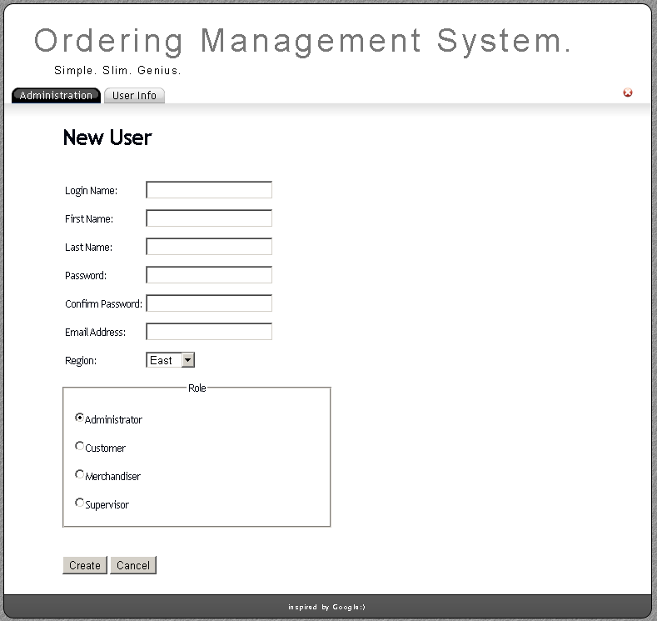

Figure 4. ‘New User’ page

These text boxes have the following format:

‘Login Name’: 25 characters mandatory field, case sensitive has to be unique. Can’t contain reserved characters (=,/, |, \, *, (, ), _, :, ;, #, %, ^, ?, [, ], etc.).etc.).If user enters in the ‘Login Name’ field existing user, the error message appears with the following text: ‘User with such login already exists’ on the right side of 'Login Name' field.

‘First Name’, ‘Last Name’: from 1 to 25 characters mandatory field, case sensitive. Can’t contain reserved characters (=,/, |, \, *, (, ), _, :, ;, #, %, ^, ?, [, ]).

‘Last Name’: 25 characters mandatory field, case sensitive. Can’t contain reserved characters (=,/, |, \, *, (, ), _, :, ;, #, %, ^, ?, [, ], etc.).

‘Password’: Symbols entered in ‘Password’ field are transformed in asterisks at once after entering. Cannot be shorter than 4 characters and longer than 10 mandatory field.

’Confirm Password’: Symbols entered in ’Confirm Password’ field are transformed in asterisks at once after entering. ‘Confirm Password’ must be the same as entered data in ‘Password’ text box.

‘Email Address’: mandatory field, according following format: [local-part@domain.com](mailto:local-part@domain.com)

**Fields validation on the ‘New User’ page.**

If entered data is invalid in:

‘Login Name’/’First Name’/’Last Name’ text boxes:

User will get an error in red color with the following message when trying to enter more than 25 characters: ‘Login name is too long’/ ‘First name is too long’ / ‘Last Name is too long’ on the right side of corresponding fields.

User will get an error in red color with the following message when trying to enter reserved characters: ‘Login name cannot contain reserved characters’/‘First name cannot contain reserved characters’ / ‘Last Name cannot contain reserved characters’ on the right side of corresponding fields.

When user doesn’t enter any data in this field after clicking ‘Create’ button the next message appears: ‘Login name cannot be blank’ / ‘First name cannot be blank’ / ‘Last name cannot be blank’ on the right side of corresponding fields.

‘Password’/’Confirm Password’ text boxes:

User will get an error in red color with the following message when trying to enter less than 4 or more than 10 symbols in ‘Password’ field: ‘Password cannot be shorter than 4 and longer than 10 characters’ on the right side of corresponding fields.

When user doesn’t enter any data in ‘Password’ field after clicking ‘Create’ button the next message appears: ‘Password cannot be blank’ on the right side of ‘Password’ field.

If entered data in ‘Password’ field isn’t the same as entered data in ‘Confirm Password’ the next message appears: ‘Confirm password has to be equal to password’ on the right side of ‘Confirm Password’ field.

‘Email Address’ text box:

Will get an error in red color with the following message: ‘You should use valid email address’ on the right side of ‘Email Address’ field.

When user doesn’t enter any data in this field after clicking ‘Create’ button the next message appears: ‘Email Address cannot be blank’.

‘Create’ button accepts entered data, if valid, and stores it to the database, and returns user to main page on the ‘Administration’ tab.

‘Cancel’ button doesn’t store any entered data to the database and returns user to the main page on the ‘Administration’ tab.

‘Administration’ tab with error messages is added in Figure 5. ‘Administration’ tab with error messages.

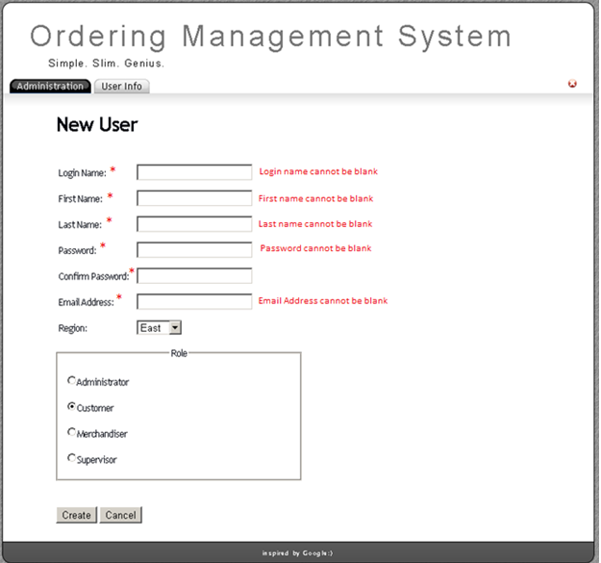

Figure 5. ‘Administration’ tab with error messages

***3.2.4 ‘Edit User’ page***

The ‘Edit User’ page allows Administrator to edit information about existing user (Fig.6). The page consists of ‘Login Name’, ‘First Name’, ‘Last Name’, ‘Password’, ‘Confirm Password’, ‘Email Address’ text boxes; ‘Region’ drop down list with 4 items (‘East’, ‘West’, ‘South’, ‘North’); ‘Role’ group box with 4 radio buttons(‘Administrator’, ‘Customer’, ‘Merchandiser’, ‘Supervisor’) with possible to choose only one role; ‘Create’ and ‘Cancel’ buttons. Default states of all controls looks like as mockup (Figure 4). All controls should contain information of a chosen user, except ‘Password’ and ‘Confirm Password’ fields (they are empty).

The ‘Edit User’ page is depicted in Figure 4 below.

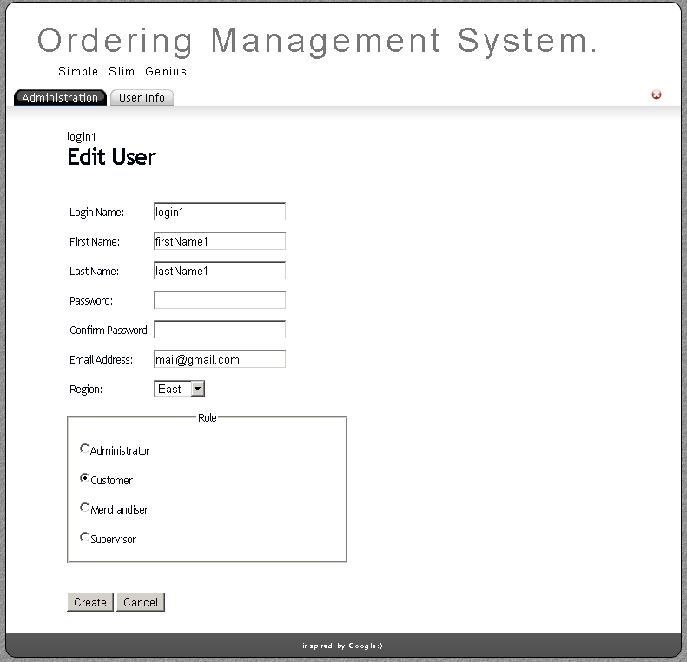

Figure 6. ‘Edit User’ page

When editing user, this action simply updated the database for the user that is currently being edited based on the data entered and then leaves the fields displaying the entered data.

Validation and format of entered fields on ‘Edit User’ page are the same as for ‘New User’ page (described above).

‘Create’ button accepts entered data, if valid, and stores it to the database, and returns user to main page on the ‘Administration’ tab.

‘Cancel’ button doesn’t store any entered data to the database and returns user to the main page on the ‘Administration’ tab.

***3.2.5 ‘Delete’ button functionality***

Administrator can delete user by clicking ‘Delete’ link. If Administrator deletes a user, dialog window (Figure 7) appears with the following message: ‘The user will be deleted from the List of Users. Are you sure you want to proceed?’ ‘OK’ button in dialog window deletes chosen user from the List of Users. ‘Cancel’ button cancels the operation of deletion.

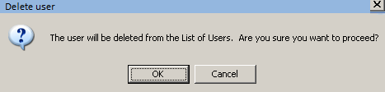

Figure 7. Dialog box ‘Delete user’

***3.2.6 ‘Create report’ page***

‘Create report’ page depicted on Figure 8.

Consist of:

‘Save report’ link. Clicking on ‘Save report’ link allows the administrator to create a ‘User report’ in*.pdf format. ‘User report’ is shown in mockup (Figure 9). Clicking on ‘Save report’ link without using ‘Search by’ options allows the administrator to create ‘User report’ which contains a list of all users in the application at the current date. When administrator clicks on ‘Save report’ link after selecting any field filter and presses ‘Search’ button, ‘User report’ contains a list of all users in the application at the current date, which matches filter criteria.

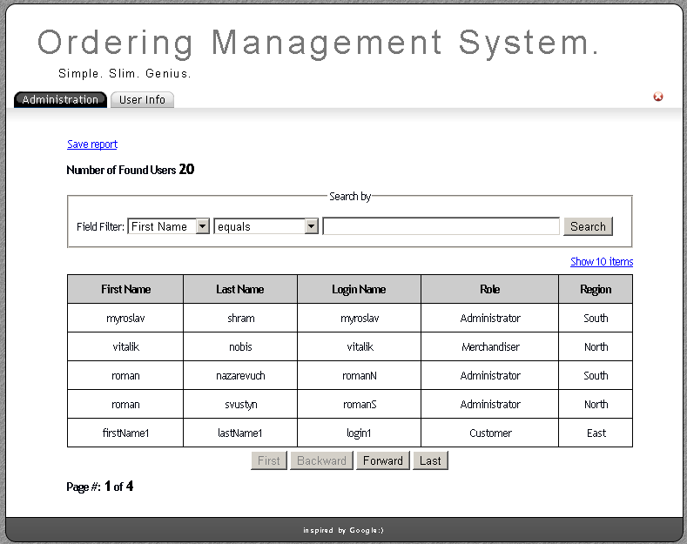

Figure 8. ‘Create Report’ page

‘Number of Found Users’ shows the number of found users during the last search. In case if search was not performed, this amount is equal to the number of all users that exist in the system.

‘Search by’ can be done by filling in 3 fields.

To perform search, user chooses necessary option from dropdown list, enters data in text box and click ‘Search’ button. After that search results are displayed. If there are no results, grid with list of products is empty. To display all products and clear search result, user can return drop down lists to its default state and clear text box field and click ‘Search’ button.

‘Select Field’ drop down list contains the following values: First Name, Last Name, User Name, Region, Role. Default value for ‘Select field’ is ‘First Name’.

‘Select Condition’ drop down list contains the following values: equals, not equal to, starts with, contains, does not contain. Default value for ‘Select condition’ is ‘equals’.

Text box for entering searching information is empty by default with the following format: 25 characters, case insensitive. User will get an error in red color with the following message when trying to enter more than 25 characters: ‘Maximum length of search text is 25 characters’ below text field. The Users’ table is displayed without changes according to selected search filters.

‘Search’ button for confirmation searching with selected filters.

‘Show 10/5 items’ link. Section ‘Show 10/5’ items link is below ‘Search by’ button. By default its state is ‘Show 10 items’ and not more than 5 items are displayed per page. Clicking on this element forces showing 10 items per page and state of the control is changed to ‘Show 5 items’.

‘Users’ table

Grid with such columns: ‘First name’, ‘Last Name’, ‘Login’, ‘Role’ and ‘Region’ displays information about users.

‘First Name’ displays user’s first name;

‘Last name’ displays user’s last name;

‘Login’ displays user’s login name;

‘Role’ displays user’s role;

‘Region’ displays user’s region

The list of users is sorted by the order of their creation by default. The items in the user’s table can be sorted by all columns in ascending or descending order by clicking the corresponding column header. On the first click of a column header, the list is sorted by ascending order based on corresponding column header. If the same column header is clicked a second time, the list is sorted by descending order based on corresponding column header.

Navigation buttons’ ‘First’, ‘Backward’, ‘Forward’ ‘Last’ buttons’ are described in the Table 1.

‘Page #:’ indicator shows number of page and total count of pages.

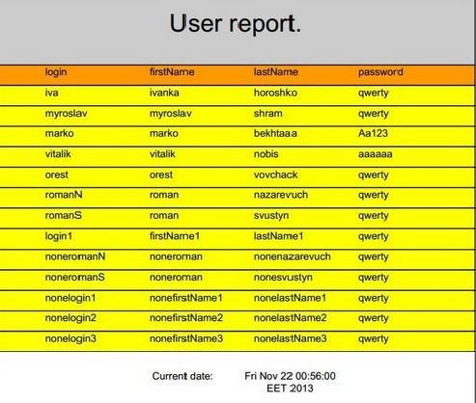

Figure 9. User report

***3.2.7 ‘User Info’ tab***

The ‘User Info’ tab allows Administrator to view information about himself. There are 3 fields: ‘First Name’, ‘Last Name’ and ‘Role’ on this page. The page is shown in Figure 10.

‘English’ and ‘Українська’ links allow user to change localization of the page. Detailed info Tab.1 on the beginning of document.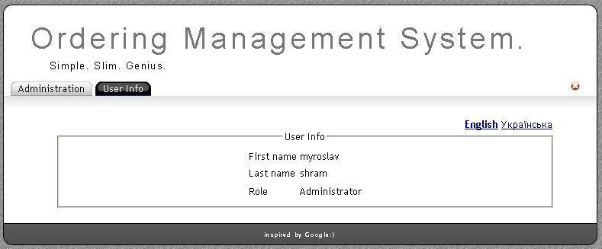Figure 10. ‘User info’ page

***3.3 ‘Merchandiser’ role***

Merchandiser user sees the following tabs: ‘Ordering’, ‘User Info’. ‘Ordering’ tab consists of ‘Order’ page, and ‘Edit order’ page. ‘User Info’ tab is opened by default. Merchandiser user can switch between tabs, clicking on the corresponding tab. Tabs don’t change default state after switching between them.

***3.3.1 ‘Ordering’ tab***

Ordering tab is used for sorting, searching, filtering, editing and deleting existing orders. On this page user can filter existing orders by ‘Status’, search orders by ‘Order Name’, ‘Assignee’, sort orders by columns, edit and delete existing orders. User sees all comments, but can edit and delete only which are assigned to him. The page is depicted in Figure 11.

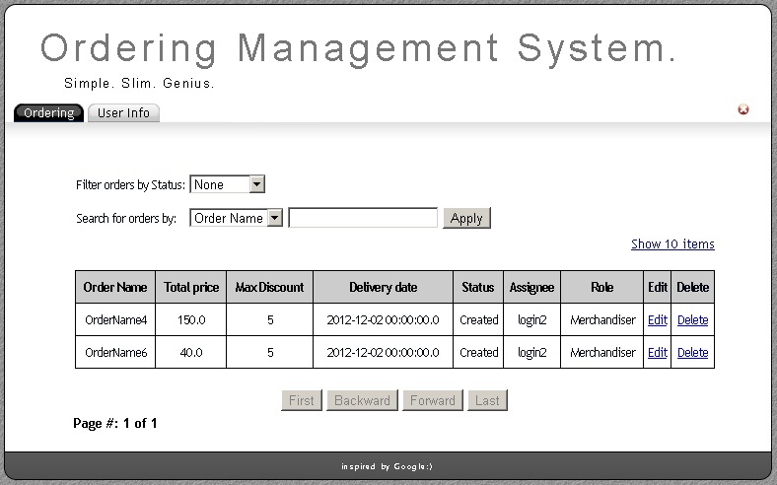

Figure 11. ‘Ordering’ tab for ‘Merchandiser’ role

Ordering tab consist of the following elements:

‘Filter orders by Status’ has following options: None (default), Created, Pending, Ordered, Delivered (selected in dropdown list).

‘Search for orders by’ can be done by ‘Order Name’ (default) or ‘Assignee’ (selected in dropdown list). Search information is entered into text box field (case

insensitive, empty by default). User will get an error in red color with the following message when trying to enter more than 25 characters: ‘Maximum length of search text is 25 characters’. Search is performed by pressing ‘Apply’ button.

User gets a message when searching values don’t exist in the system: ’There are no orders meet specific criteria’.

Show 10 Items/Show 5 Items – link ‘Show 10 Items’ means that for the present moment only 5 orders are shown per page. Clicking on this link forces showing of 10 orders per page and link is changed to ‘Show 5 Items’. 5 items is showing by default.

The information about orders is in the table. Table consists of 8 columns:

‘Order Name’. This information is automatically generated as ‘OrderName#’, where # is order number.

‘Total price’. Total price of all items in the order.

‘Max Discount’. Discount set for this order (defined by Customer type).

‘Delivery Date’. Delivery date set for this order by merchandiser.

‘Status’. Current order’s status.

‘Assignee’. Current merchandiser login assigned to this order.

‘Edit’. Order can be edited after pushing ‘Edit’ button.

‘Delete’. Order can be deleted by pressing ‘Delete’ button. The following confirmation dialog box appears after pushing button. The confirmation dialog box is depicted on Figure 12.

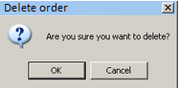

Figure 12. ‘Delete order’ confirmation dialog box

The list of orders will be sorted in the order of their creation by default. The items in the order table can be sorted by all columns in ascending or descending order by clicking the corresponding column header. On the first click of a column header, the list will be sorted in ascending order based on the column whose header was clicked. If that same column header is clicked a second time in a row, then the list will be sorted in descending order based on that column.

Navigation buttons ‘First’, ‘Backward’, ‘Forward’ ‘Last’ buttons behavior is described in Table 1.

‘Page #:’ indicator show number of the page, on which user is present and total count of the pages.

Logout button is described in Table 1.

***3.3.2 ‘Edit Order’ page***

The ‘Edit Order’ page allows ‘Merchandiser’ to edit some information about existing order. The page is depicted in Figure 13.

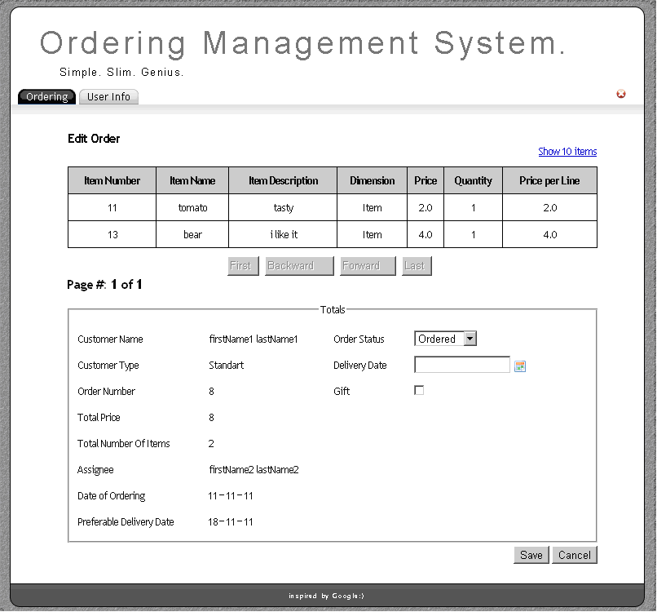

Figure 13. ‘Edit Order’ page for ‘Merchandiser’ role

‘Edit Order’ page consists of:

Show 10 Items/Show 5 Items – link ‘Show 10 Items’ means that for the present moment only 5 orders are shown per page. Clicking on this link forces showing of 10 orders per page and link is changed to ‘Show 5 Items’. 5 items is showing by default.

The information about products is in the table. Table consists of 7 columns:

‘Item Number’ – items’ number remembered from ‘Product’ table

‘Item Name’ – name of item remembered from ‘Product’ table

‘Item Description’ – items’ description remembered from ‘Product’ table

‘Dimension’ – container of item remembered from orders creation page

‘Price’ – price of item remembered from ‘Product’ table

‘Quantity’ – quantity of items remembered from orders creation page

‘Price per Line’ – ‘Price per Line’ is calculated with following formula:

If ‘Item’ dimension is selected: ‘Price per Line’ = ‘Price’ * ‘Quantity’;

If ‘Box’ dimension is selected: ‘Price per Line’ = 5 * ‘Price’ * ‘Quantity’;

If ‘Package’ dimension is selected: ‘Price per Line’ = 10 * ‘Price’ * ‘Quantity’.

The list of items will be sorted in the order they were added by default. The items in the table can be sorted by columns in ascending or descending order by clicking the corresponding column header. On the first click of a column header, the list will be sorted in ascending order based on the column whose header was clicked. If that same column header is clicked a second time in a row, then the list will be sorted in descending order based on that column.

Navigation buttons ‘First’, ‘Backward’, ‘Forward’ ‘Last’ buttons behavior is described in Table 1.

‘Page #:’ indicator should show number of the page, on which user is present and total count of the pages.

‘Totals’. Information about order is displayed in form and include following controls:

‘Customer Name’ – first name and last name of customer who created current order (uneditable field).

‘Customer Type’ – customer type (uneditable field)

‘Order Number’ – order number (uneditable field)

‘Total Price’ – sum of all cells from ‘Price per Line’ (uneditable field)

‘Total Number Of Items’ – number of items from current order (uneditable field)

‘Assignee’ – first name and last name of merchandiser who was chosen in order creation page (uneditable field)

‘Date of Ordering’ – date of order creation (uneditable field)

‘Preferable Delivery Date’ – selected by Customer, can’t be earlier than ‘Date of Ordering’ (uneditable field).

‘Order Status’ – drop down list with following options: ‘Created’, ‘Ordered’, ‘Pending’, ‘Delivered’.

These values are selected from the database for current order.

‘Delivery Date’ – mandatory text box with ‘Date Picker’. Text field is empty by default. Can’t be earlier than current date. (uneditable field)

‘Gift’ – checkbox which allows merchandiser to add gift to current order. Checkbox is unchecked by default.

‘Save’ button – allows to save order with edited data. After clicking on ‘Save’ button ‘Ordering’ tab is opened and comment with edited data is displayed in ‘Orders’ table.

‘Cancel’ button – allows to return to ‘Ordering’ tab without changing an order.

***3.3.3 ‘User Info’ tab***

The ‘User Info’ tab allows Merchandiser to view information about himself. There are 3 fields: First Name, Last Name and Role on this page. This information is remembered from Users’ system registration. The page is depicted in Figure 14.

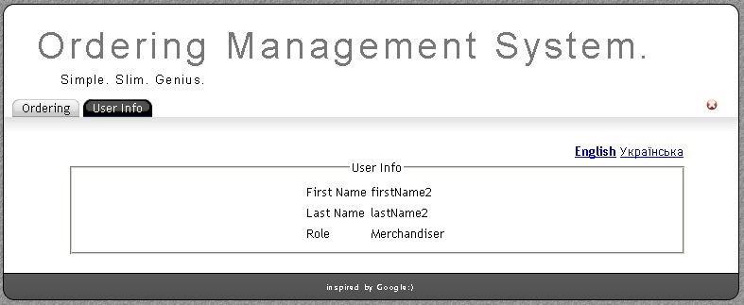

Figure 14. ‘User Info’ tab for ‘Merchandiser’ role

The ‘English’ and ‘Українська’ links allows user to change localization of page. Detailed information depicted on Table 1 on the beginning of document.

***3.4 ‘Customer’ role***

‘Customer’ user sees the following tabs: ‘Ordering’, ‘User Info’. ‘Ordering’ tab consists of ‘Create new order’ page, ‘Edit order’ page, ‘Add item’ page and ‘Edit item’ page. ‘User Info’ tab is opened by default. ‘Customer’ user can switch between both tabs, clicking on the corresponding tab. Tabs don’t revert to default state after switching between them.

***3.4.1 Ordering’ tab***

Ordering tab is used for sorting, searching and filtering existing orders and for creating new orders. On this page user can filter existing orders by ‘Status’, search orders by ‘Order Name’, ‘Assignee’ and sort orders by columns. The page is depicted in Figure 15.

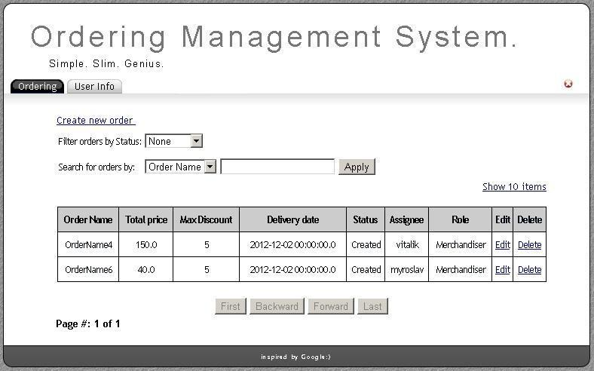

Figure 15. ‘Ordering’ tab for Customer

Ordering tab consists of the following elements:

‘Create new order’ link navigates to ‘Create new order’ page.

‘Filter orders by Status’ has following options selected in dropdown list: None (default), Created, Pending, Ordered, Delivered, Canceled.

‘Search for orders by’ can be done by Order Name (default) or Assignee (selected in dropdown list). Search information is entered into text box field (case insensitive, empty by default). User gets an error in red color below current field with the following message when trying to enter more than 25 characters: ‘Maximum length of search text is 25 characters’. Search is performed by pressing ‘Apply’ button.

User gets a message when searching values don’t exist in the system: ’There are no orders meet specific criteria’

Table with information about orders consists of 9 columns:

* ‘Order Name’. This information is automatically generated as ‘OrderName#’, where # is order number.
* ‘Total price’. Total price of all items in the order.
* ‘Max Discount’. Discount set for this order (defined by Customer type).
* ‘Delivery Date’. Delivery date set for this order by merchandiser.
* ‘Status’. Current order’s status.
* ‘Assignee’. Merchandiser assigned to this order.
* ‘Role’. Role of the user, assigned to this order.

- ‘Edit’. Order can be edited after clicking ‘Edit’ link. ‘Edit order’ page looks like ‘Create new order’ page, but with values entered from the database. ( Figure 16) Only order with status ‘Created’ can be edited. When clicking ‘Edit’ on order with different status, customer can only view items in it (Only ‘Item Selection’ section of ‘Edit order’ page is present with no ‘Edit’ or ‘Delete’ columns).

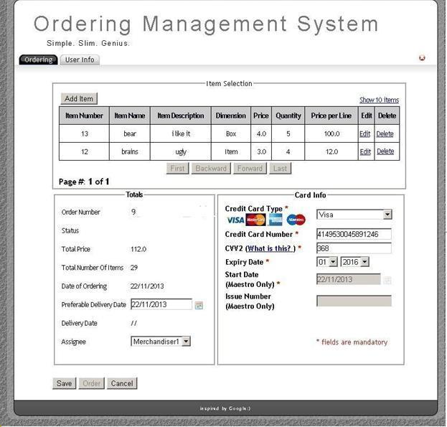

Figure 16.‘Edit order’ page of ‘Ordering’ tab for Customer.

* ‘Delete’. Order can be deleted by clicking ‘Delete’ link. The following confirmation dialog box appears after clicking link (Figure 17).



Figure 17. ‘Delete order’ confirmation dialog box.

Only orders made by currently logged in customer are displayed.

The list of orders is sorted in the order of their creation by default. Items in the order table can be sorted by all columns, except of ‘Edit’ and ‘Delete’ columns, in ascending or descending order by clicking the corresponding column header. On the first click on a column header, the list is sorted in ascending order based on the corresponding column header. If that same column header is clicked a second time in a row, then the list is sorted in descending order based on the corresponding column header.

By default 5 items are viewed per page. It can be changed to 10 items per page by clicking ‘Show 10 items’ link. After clicking on link, it changes to ‘Show 5 items’. Clicking it changes back table to showing 5 items per page again.

Navigation buttons ‘First’, ‘Backward’, ‘Forward’ ‘Last’. All buttons should be inactive, if number of items is 10 or less when displaying 10 items per page and 5 or less when displaying 5 items per page. ‘Backward’ and ‘First’ buttons should be inactive if user is on the first page. ‘Forward’ and ‘Last’ buttons should be inactive if user is on the last page.

‘Page #:’ indicator shows number of the page, on which user is present and total count of the pages.

‘Logout’ button: after clicking on ‘Logout’ button user logouts from system and returns to ‘Login’ page.

***3.4.2 ‘Create new order’ page of ‘Ordering’ tab***

‘Create new order’ page is used for providing information about new order (Figure 18).

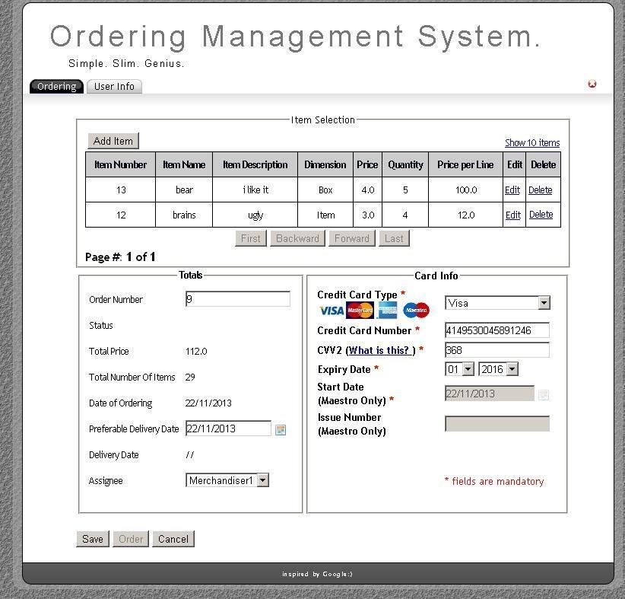

Figure 18.‘Create new order’ page of ‘Ordering’ tab for Customer.

‘Create new order’ page consists from the following elements:

**‘Item Selection’ section:**

‘Add Item’ button navigates to ‘Add Item’ page.

Added items are displayed in the table that consists of 9 columns: Item Number, Item Name, Item Description, Dimension, Price, Quantity, Price per Line, Edit, Delete.

Customer selects item, ‘Dimension’ (Item, Box, Package) and ‘Quantity’. Rest of values are entered from the database according to the chosen item. ‘Price per Line’ is calculated with following formula:

If ‘Item’ dimension is selected: *‘Price per Line’ = ‘Price’ * ‘Quantity’*;

If ‘Box’ dimension is selected: *‘Price per Line’ = 5 * ‘Price’ * ‘Quantity’*;

If ‘Package’ dimension is selected: *‘Price per Line’ = 10 * ‘Price’ * ‘Quantity’*.

Added item can be edited by clicking on ‘Edit’ link. ‘Edit Item’ page is similar to ‘Add Item’ page, but with values entered from the database.

The list of items is sorted in the order as they were added by default. The items in the table can be sorted by columns 1-7 in ascending or descending order by clicking the corresponding column header. On the first click on a column header, the list is sorted in ascending order based on the corresponding column header. If that same column header is clicked a second time in a row, then the list is sorted in descending order based on the corresponding column header.

By default 5 items are viewed per page. This can be changed to 10 items per page by clicking ‘Show 10 items’ link. After clicking it changes to ‘Show 5 items’. Clicking it changes back table to showing 5 items per page again.

Navigation buttons ‘First’, ‘Backward’, ‘Forward’ ‘Last’ behavior is described in Table 1.

All buttons should be inactive, if number of items is 10 or less when displaying 10 items per page and 5 or less when displaying 5 items per page. ‘Backward’ and ‘First’ buttons should be inactive if user is on the first page. ‘Forward’ and ‘Last’ buttons should be inactive if user is on the last page.

‘Page #:’ indicator shows number of the page, on which user is present and total count of the pages. For example: Page #: 1 of 3 indicates that user is on first page, totally 3 pages are present.

**‘Totals’ section:**

‘Order number’ – non editable mandatory auto generated number field according to last used order number. Range of numbers are from 1 to 2 147 483 647.

‘Status’ – non editable field, which displays order status. It is empty while customer creates new order. It changes its value to ‘Created’ after clicking ‘Save’ button.

‘Total price’ – non editable field, auto calculated according to added items with following formula:

*‘Total price’ = sum of ‘Price per line’ for all added items.*

‘Total Number Of Items’ – non editable field, auto calculated based on added items.

‘Date of Ordering’ – non editable field, auto filled with current date.

‘Preferable Delivery Date’ – mandatory non editable text box with ‘Date Picker’. Text field is empty by default and can be selected by Customer, can’t be earlier than current date.

‘Delivery Date’ – empty (‘//’), can be entered later by Merchandiser.

‘Assignee’ – drop down list of Merchandisers. Default selection is ‘-me-‘. Merchandiser must be assigned to the order. If Merchandiser is not assigned (selection is left on ‘-me’) user gets an error in red color with the following message: ‘Please assign your order to merchandiser’ below current field after trying to save an order.

**‘Card Info’ section:**

‘Credit Card Type’ – drop down list with following options: Visa (selected by default), MasterCard, American Express, Maestro.

‘Credit Card Number’ – mandatory number field,must be 16 numbers long. When ‘Credit Card Number’ information is wrong and customer tries to save an order error dialog box with the following text appears: ‘Credit Card Number is incorrect. Please re-type it again’.

‘CVV2’ – number field, mandatory, must be 3-4 numbers long. Pop-up page with explanation what is CVV2 number is displayed when customer clicks on ‘What is this?’ link. When ‘CVV2’ information is wrong error dialog box with the following text appears: ‘CVV2 is incorrect. Please re-type it again’ appears after trying to save an order.

‘Expiry Date’ – Customer can select month and year of expiration of his card from drop down list. Available months are 01-12, years: 2011-2037. ‘01’ ‘2011’ is selected by default.

‘Start Date (Maestro Only)’ – text box with ‘Date Picker’, non editable, text field is empty by default, mandatory, can be selected by Customer, can’t be earlier than current date, only available when ‘Maestro’ card type is selected.

‘Issue Number (Maestro Only)’ – number field, 1 or 2 numbers long, not mandatory, only available when ‘Maestro’ card type is selected.

‘Credit Card Number’ is validated first, ‘CVV2’ – second.

**Confirmation buttons:**

‘Save’ – checks if order is not empty and if all mandatory fields from ‘Totals’ section are entered and are correct and saves order to the database. Order status changes to ‘Created’. If used when editing existing order with ‘Created’ status simply updates database with newly entered data.

‘Order’ – is disabled by default. If customer created order by clicking on ‘Save’ button, it becomes enabled. ‘Order’ button checks if order is not empty and if all mandatory fields from ‘Totals’ and ‘Card Info’ sections are entered and are correct and saves order to the database. Order status changes to ‘Ordered’ and it becomes closed for editing.

‘Cancel’ – returns to ‘Ordering’ page.

***3.4.3 ‘Add Item’ page of ‘Ordering’ tab***

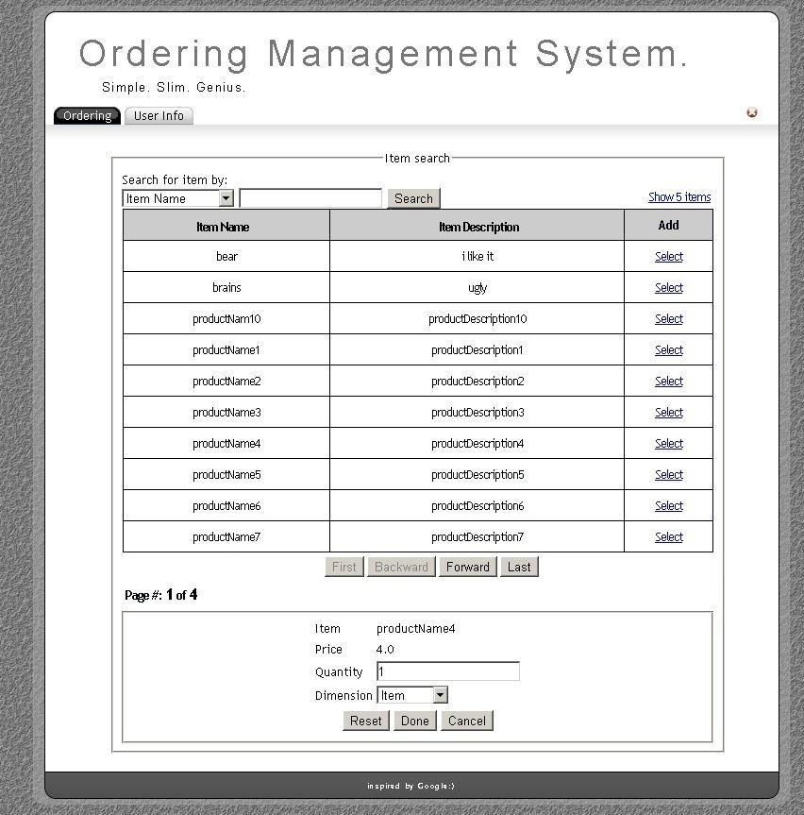

Figure 19. ‘Add item’ page of ‘Ordering’ tab for Customer.

‘Add Item’ page is used for adding items to new order. The page is depicted in Figure 19.

‘Add item’ page consists of the following elements:

‘**Item Search’ section:**

* ‘Search for Item by’ can be done by ‘Item Name’ (default) or ‘Item Description’ (selected in dropdown list). Search information is entered into text box field (case insensitive, empty by default). User gets an error in red color with the following message when trying to enter more than 25 characters after clicking ‘Search’: ‘Maximum length of search text is 25 characters’. Search is performed by clicking ‘Search’ button.

User gets a message when searching values don’t exist in the system: ’There are no orders meet specific criteria’

* Available items are displayed in the table that consists of 3 columns:

Item Name, Item Description (values are selected from the database) and Add.

By clicking ‘Select’ link in the ‘Add’ column corresponding item is selected for adding.

* By default 5 items are viewed per page. This can be changed to 10 items per page by clicking ‘Show 10 items’ link. After clicking it changes to ‘Show 5 items’. Clicking it changes back table to showing 5 items per page again.
* Navigation buttons ‘First’, ‘Backward’, ‘Forward’ ‘Last’ behavior is described in Table 1.
* ‘Page #:’ is described in Table 1.

**Item properties section:**

* ‘Item’ field – by default is empty, after clicking ‘Select’ link it displays currently selected item.
* ‘Price’ field – empty by default , after clicking ‘Select’ link it displays currently selected item price.
* ‘Quantity’ – number field, mandatory, range of values are from 1 to 1000, default value is ‘1’. User gets an error in red color with the following message under this field when trying to enter inappropriate data to this field after pressing ‘Done’ button: ‘Quantity must be number from 1 to 1000’.
* ‘Dimension’ – drop down list for choosing dimension for currently selected item. Available options are: Item, Box (5 items), Package (10 items). Default state is ‘Item’.

**Confirmation buttons section:**

* ‘Reset’ – clears currently selected Item and price, resets quantity to ‘1’ and dimension to ‘Item’.
* ‘Done’ – validates fields and adds item to the order.
* ‘Cancel’ – returns to ‘Create new order’ page.

Logout button is described in Table 1.

***3.4.4 ‘User Info’ tab***

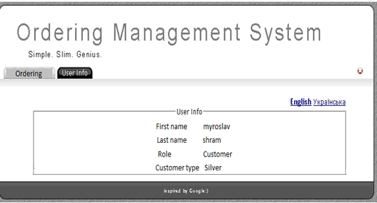

Figure 20. ‘User Info’ tab for Customer

‘User Info’ tab is used to display information about currently logged in user. There are 4 fields: First Name, Last Name, Customer Type and Role on this page. This information is remembered from Users’ system registration. The page is depicted in Figure 20.

‘English’ and ‘Українська’ links allow user to change localization of page. ‘English’ is enabled by default, it means that English localization is enabled. The ‘Українська’ link changes localization to Ukrainian. Currently selected option is displayed in bold letters.

Logout button is described in Table 1.

Customer type is assigned according to total orders sum:

Standard (no discount): 0-1000

Silver (5% discount): 1000-3000

Gold (10% discount): 3000-10000

Platinum (15% discount): 10000+

***3.5 ‘Supervisor’ role***

Supervisor user sees the following tabs:  ‘Item Management’, ‘User Info’.

‘User Info’ tab should be opened by default. Supervisor user can switch between tabs, clicking on the necessary one. Tabs don’t revert to default state after switching between them.

***3.5.1 ‘ Item Management’ tab***

On this page supervisor can observe list of products, edit, filter, add, delete them and create reports.

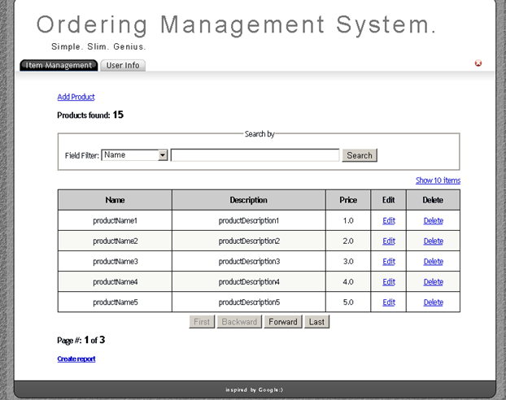

Figure 21. ‘Item Management’ tab

It consists of the following elements:

* ‘Add Product’ link.
* ‘Number of Found Users’ shows the number of found users during the last search. In case if search was not performed, this amount is equal to the number of all users that exist in the system.
* ‘Search by’ section

This section contains drop down list with two options – ‘Name’ (set by default) and ‘Description’. Supervisor is able to search products by their names and descriptions. They are empty by default, editable text box , where user can enter data to be searched. Third element of this section is ‘Search’ button, which performs search action by clicking on it.

To perform search, user chooses necessary option from dropdown list, enters data to be searched in text box and presses ‘Search’ button. Than search results are displayed. If there are no results, grid with list of products is empty. To display all products and clear search result, user deletes all data in text box field and presses ‘Search’ button.

* ‘Show 10 items/Show 5 items’ link works as described in Tabl.1

Below ‘Field filter’ ‘Show 10/5’ items is present. By default its state should be ‘Show 10 items’ and not more 5 items should be displayed per page. Clicking on this element forces showing of 10 items per page and state of the control is changed to ‘Show 5 items’.

* ‘Products’ table

Grid with such labels of columns: ‘Name’, ‘Description’, ‘Price’, ‘Edit’ and ‘Delete’ should be present. This grid displays products and information about them, search results and gives possibility to edit or delete existing product. ‘Name’, ‘Description’, ‘Price’ properties should be read-only and display corresponding information about the product. ‘Edit’ and ‘Delete’ are links, which should lead to ‘Edit’ page and ‘Delete’ action, which are described below, and should be used to edit products’ properties or to delete product.

The list of products is sorted in the order of their creation by default. The items in the table can be sorted by all columns in ascending or descending order by clicking the corresponding column header. On the first click of a column header, the list will be sorted in ascending order based on the column whose header was clicked. If that same column header is clicked a second time in a row, then the list will be sorted in descending order based on that column.

* Navigation buttons ‘First’, ‘Backward’, ‘Forward’ ‘Last’ behavior is described in Table 1.
* ‘Page #:’ indicator shows number of the page, on which user is present and total count of the pages.
* ‘Create report’ link-opens ‘Create report’ page.

***3.5.2 ‘Add product’ page***

Supervisor can access ‘Add Product’ page by clicking ‘Add Product’ link.(page depicted in Figure 22). Label of the tab remains ‘Item management’. There are 3 editable text box fields for entering new data. They are empty by default. Validation of these fields is provided after clicking ‘OK’ button in such sequence: ‘Product name’ -> ‘Product description’ -> ‘Product price’. After appearing of error message, user remains on ‘Add product’ page, all data should remain in previously entered state before validating action.

‘Product Name’ field is mandatory, case insensitive, responsible for name of new product and should contain alphanumeric characters and/or numbers up to 25 characters length. If entered characters are invalid, following error message should appear below this field in red color ‘Please enter alphanumeric characters’.

If entered text is >25 characters, following error message should appear below this field in red color ’Product name is too long, please enter less than 10 characters’ Field should be highlighted in red. If field is empty and user tries to click on ‘OK’ button, following error message should appear below this field in red color should appear: ‘Please enter product name’.

‘Product Description’ field is optional, can contain special symbols, numbers and alphanumeric characters up to 25 characters length, case insensitive. If entered text is >25 characters, following error message should appear below this field in red color ’Product description is too long, please enter less than 25 characters’.

‘Product Price’ is mandatory field, can contain only numbers from 1 to 999, 1 to 3 digits length and digits can be delimited by dot. If entered characters are invalid, following error message will appear below this field in red color ‘Please enter only numbers’. Field is highlighted in red.  If entered text is >999 or <1, following error message appears below this field in red color ‘Please enter price in range of 1-999’. If field is empty and user tries to click on ‘OK’ button, following error message will appear below this field in red color: ‘Please enter product price’.

Two buttons are present below these fields, ‘OK’ and ‘Cancel’. After Clicking ‘OK’ button user returns to main page of ‘Item Management’ tab (Figure 21) and new product appears in the ‘Products’ table.

After clicking ‘Cancel’ button user returns to main page of ‘Item Management’ tab and nothing is added here.

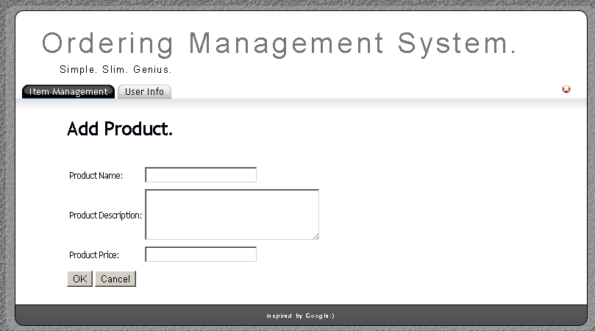

Figure 22. ‘Add product’ page

***3.5.3 ‘Edit’ page***

By pressing on ‘Edit’ link product supervisor is able to move to ‘Edit’ page, where he can edit properties of the product. General appearance of this page is described in Figure 23 and is similar to ‘Add Product’ page. Label of the tab remains ‘Item management’. There are 3 editable text box fields for entering new data. They contain data of edited product. Validation, error messages and general behavior are the same as in ‘Add item’ page . Two buttons are present below these fields, ‘OK’ and ‘Cancel’. After Clicking ‘OK’ button with valid data entered user returns to main page of ‘Item Management’ tab (Figure 21) and edited information about product can be observed in the ‘Products’ table.

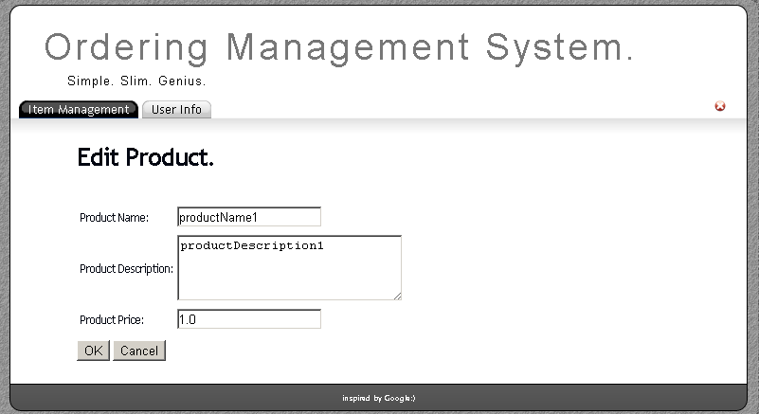

Figure 23. ‘Edit’ page

***3.5.4 ‘Delete’ action***

By pressing on ‘Delete’ link of the product supervisor is able to delete product. When user presses this link dialog box should appear depicted in Figure 24. If user clicked on ‘Ok’ button, corresponding product and all its’ properties are deleted and removed from database. If user clicked ‘Cancel’ or ‘Exit’ button, dialog box disappears and no products or data is affected.

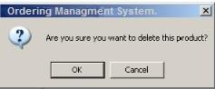

Figure 24. Dialog box on ‘Delete’ action

***3.5.5 ‘Save Report’ functionality***

By pressing ‘Save Report’ link supervisor is able to create and save reports about products and their properties  in *.pdf format. User can apply any search filter or not and click on ‘Save report’ link. After that click, page, depicted on Figure 25, is opened. If some sorting actions are performed, corresponding results will be displayed.

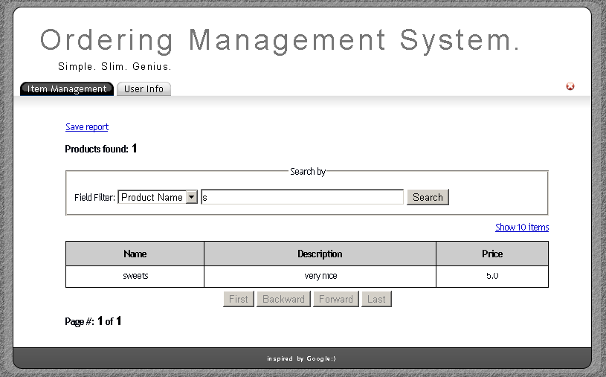

Figure 25. ‘Save report’ page

When supervisor click on ‘Save report’ link and this report should be saved in PDF format. General appearance of this report is depicted in Figure 26.

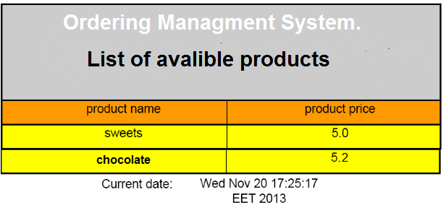

Figure 26. Product report

***3.5.6 ‘User Info’ tab***

This tab allows Merchandiser to view information about himself. There are 3 fields: First Name, Last Name and Role on this page. This information is remembered from Users’ system registration.  The page is depicted in Figure 27.

The ‘English’ and ‘Українська’ links allows user to change localization of page.

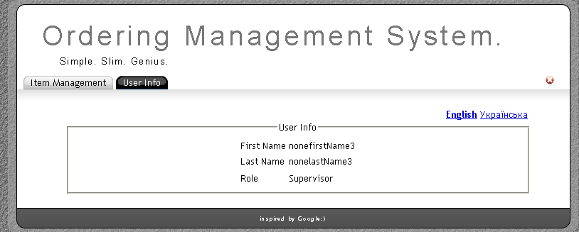

Figure 27. ‘User Info’ tab